IMT Worksheet 1

* Repository

A repository is like a project folder which contains all the project files which you included and will store each of the file’s revision history. There can be multiple collaborators which are linked to the repository and can be set to either public or private.

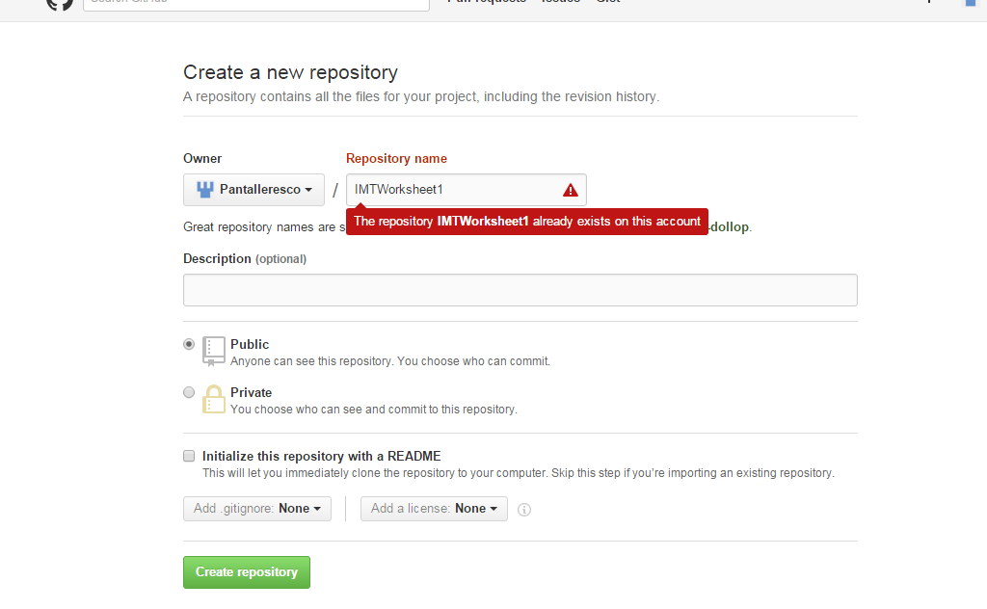

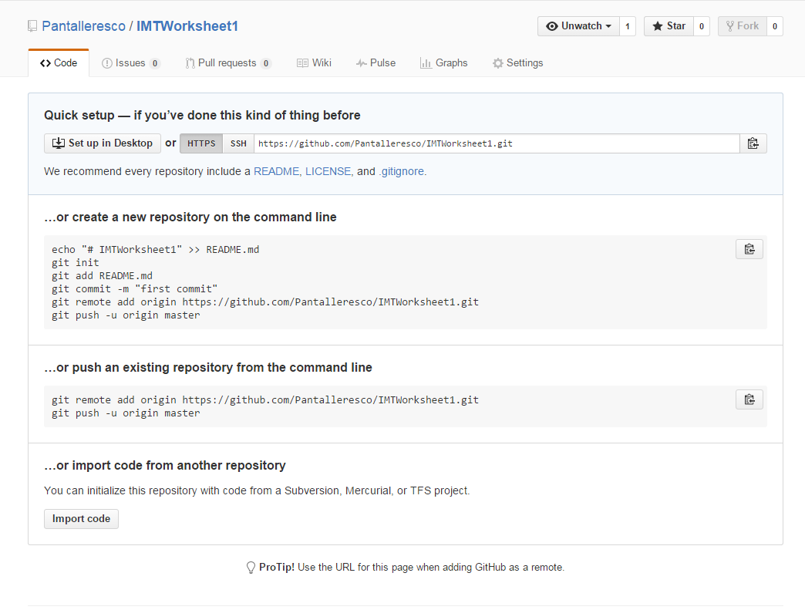

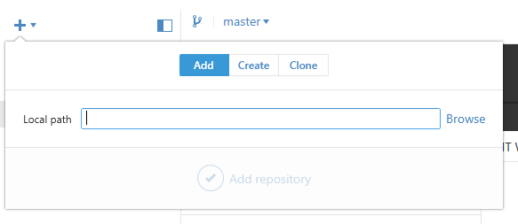

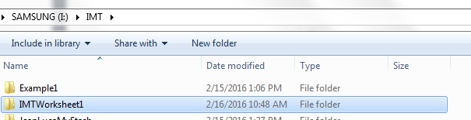

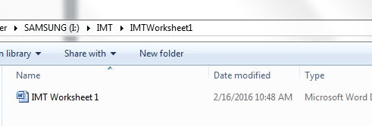

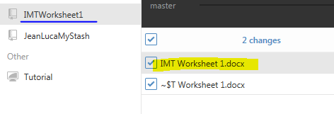

* Commit

Commit is a change in the file which you will commit to. This is the same concept as saving a file except, the main difference is that every time it creates a set of records with each its own unique ID which you can later go back to each change and review when and by who it was made.

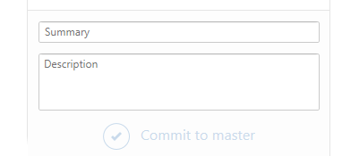

* Commit description

When pressing the commit button, you will usually include a commit message with a brief description and what changes were made. Having a description will help the person reviewing the change to understand it better.



* Github desktop

Github desktop is the main application that you install on your desktop where you can sync your repositories and track certain changes done in text files.

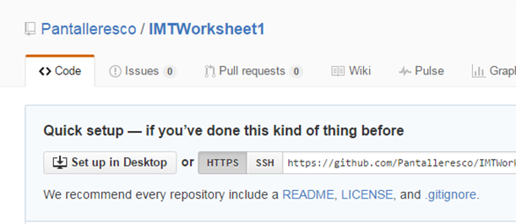

* Git Sync

Git sync is the syncing of the files from the original folder created by you to the master repository.

* What ‘download zip’ does.

It downloads the content compressing it into a .zip file.